Report of an E-commerce website created using R Studio
(Edustore)
Name: Ayça
Surname: Öngören
LECTURE: Content management systems

Project Introduction
This project was undertaken as a course requirement to develop an e-commerce site using R Shiny and ShinyDashboard libraries. The primary task of the project is the design of an interactive web shopping site that would allow buyers to view the available products and add them to a cart and also view the orders.

The project centers on selling educational resources such as books, e-learning programs, and online coursework. Each component of the system has been developed using R and implemented in the R Studio environment.

Project Objectives
The aim of this project is to provide a platform where users can manage a shopping cart by adding or removing items from a comprehensive product table that includes prices, inventory levels, and ratings. The system is designed to automatically update stock levels based on user actions while generating real-time sales and order reports. Furthermore, it enables the visualization of product prices and inventory through integrated graphs and provides essential contact information and location data via an embedded map. Ultimately, this project demonstrates how reactive programming can be effectively applied to simulate a practical e-commerce scenario.

Company Introduction
EduStore
EduStore is an innovative digital commerce platform offering high-quality educational materials for both students and professionals. Developed using the R Shiny framework, our system combines modern e-commerce functions with data analytics and visualization tools to provide users with a comprehensive shopping experience.
Our Vision
To become a globally trusted, leading digital marketplace for access to educational resources.
Our Mission
- To provide accessible educational materials for every budget.
- To support digital learning processes with our technological infrastructure.
- To offer a seamless and fluid shopping experience thanks to our user-friendly interface.

Platform Features and Technological Infrastructure:EduStore is not just a sales channel, but also a data-driven management panel. The key features offered by our platform are:

Dynamic Product Management: Users can browse educational materials from categorized lists, track stock levels in real-time, and perform quick name-based searches.

Smart Shopping Cart System: The shopping cart mechanism, integrated with stock control, automatically reduces stock when a product is added; The system updates the stock in real-time when a product is removed or the shopping cart is cleared.

Data Analytics and Visualization: Product stock distributions, pricing strategies, and market trends can be tracked through the Dashboard and Analytics tabs using advanced visualization tools such as "Violin Plot" and "Bar Charts".

Real-Time Status Monitoring: Thanks to the summary boxes (ValueBox) on the main page, the total number of products, total sales revenue, and the quantity of orders received can be monitored in real-time.

EduStore Products
We offer 5 different products on our website. By purchasing these products, you can lay the foundation for your software development skills.

No | Product Name | Price | Stock | Rating
1 | Python Programming Book | 750 TL | 20 pieces | 5 points
2 | Data Science Video Course | 1200 TL | 15 pieces | 5 points
3 | Web Development Notes | 300 TL | 40 pieces | 4 points
4 | SQL Practice Workbook | 450 TL | 25 pieces | 4 points
5 | Statistics Video Course | 1000 TL | 10 pieces | 5 points

EduStore Product Features
Technical Books & Workbooks: We provide basic books like “Python Programming Book” to those interested in the area of Python programming and “SQL Practice Workbook” to help gain skills in managing the database system.

Digital Video Trainings: “Data Science Video Course” is designed for consumers who learn better via visual and auditory understanding and provides real-life application solutions for complex notions in data science.

Academic and Professional Notes: "Web Development Notes" are academic guides that contain brief summaries and comments on essential information related to "Web Development." These serve as useful guides throughout the software development process.

Advanced Online Courses: Our portfolio consists of extensive online course materials like "Statistics Online Course" which is created for those professionals who want to enhance their statistical analysis skills.

EduStore Products Ratings
Product Quality Standards & User Experience: The fact is that all the material in our system is rated by the users, and the current material in the system has been well received by the users, with satisfaction rates ranging from 4 to 5 stars (points). With the search options available, the users can search for the material they want in seconds and complete their shopping.

EduStore Website Code Descriptions

Packages
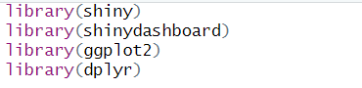
library(shiny): This is the basic library used to develop web-based interactive applications with the R programming language.
It provides the user interface (UI) and server structure.

library(shinydashboard): Used to design Shiny applications in dashboard format.
Includes components such as menus, sidebars, and value boxes.

library(ggplot2): A powerful graphics library used for data visualization.
Used in creating stock, price, and distribution graphs.

library(dplyr): Used for data manipulation.

Background Code
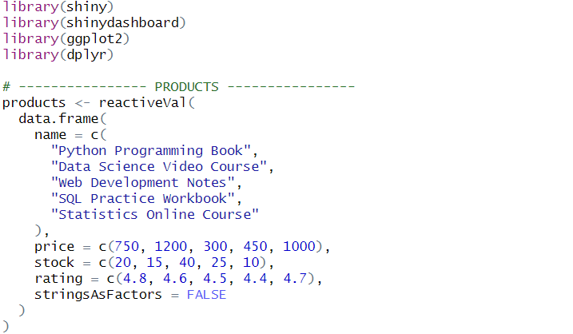
In this code, data for products for which information will be entered into the application is determined in the background. The data frame, which was established within the reactiveVal function, is a data structure where information on products in columns is stored and can be altered as long as the program is running. Because of this data frame, data on products is changed dynamically and responded to through user interactions. The information regarding price, stocks, and scores from users for products, which include training materials, is maintained, and sameness in data processing is achieved through the expression stringsAsFactors = FALSE, which discourages the transformation of text data types into factor types.

Regarding the UI part of the website
The application's user interface is designed using the ShinyDashboard architecture. The application name and a visual icon are located at the top, while the side menu allows users to navigate between Home, About Us, Materials, Shopping Cart, Contact, Dashboard, and Data Analysis pages. Blue and purple tones have been preferred in the interface design; the menu section is arranged in lilac tones, while the main content area is designed in light blue. This color scheme aims to clarify the visual separation between sections and ensure interface consistency. Menu items are structured to provide smooth transitions between pages within the application.

UI Part Code
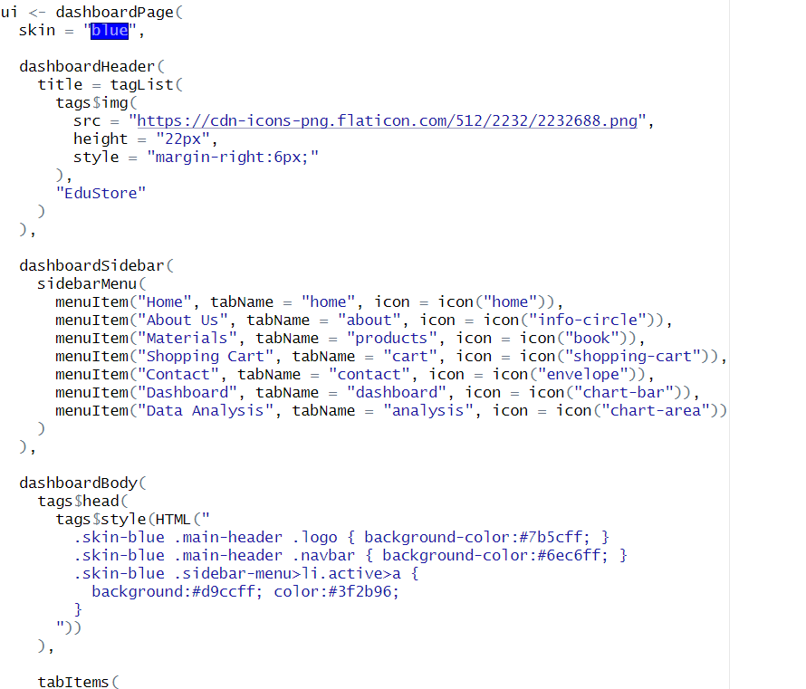
The code used on my website creates the user interface of the Shiny application using the dashboardPage structure and a blue theme (skin = "blue"). The dashboardHeader section displays the application title, a book icon, and the text "EduStore" together. The sidebar within the dashboard creates the sidebarMenu, Home, About Us, Materials, Shopping Cart, Contact, Dashboard, and Data Analysis tabs, enabling navigation between pages. In the dashboardBody section, custom color and style adjustments are made for the header, menu, and active tabs using tags$head and tags$style. The tabItems structure allows for the addition of content areas corresponding to each menu item, thus completing the overall interface structure and navigation of the application.

Website Pages

1- Home Page
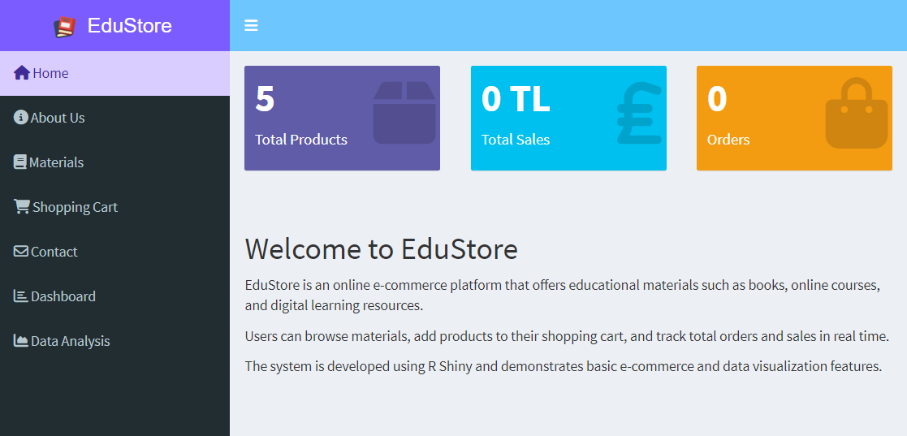

At the top of this page, you'll find three main dashboards displaying real time data from the database:

Total Products: Shows the total number of different products registered in the system. In other words, it shows how many different products we have.

Total Sales: Shows the total amount of sales in Turkish Lira (TL).

Total Orders: Shows the total number of orders placed through the system

The Shiny dashboard package was used to create the header, sidebar, and body sections of this page.

When items are added to or removed from the cart, the dashboard looks like this:
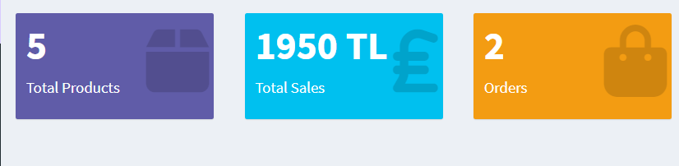

Welcome Section: Below this dashboard, you will find a text describing the company and its contents.

Home Page Code
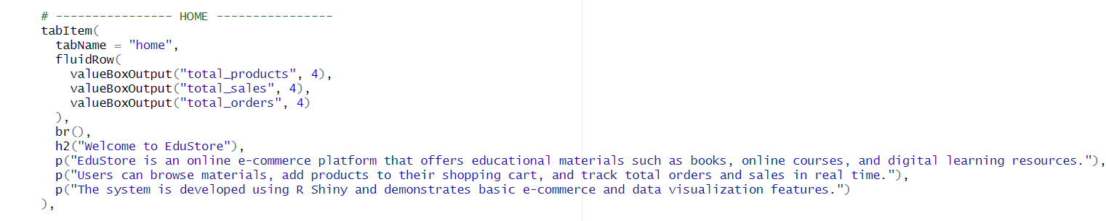

tabItem: This is used to define the contents of the tabs within the Dashboard. This section defines the screen that will be displayed when the “Home” tab is clicked.

tabName= “home” : This is the tab's name. When the user clicks "Home" in the menu, it displays the "Home" content on the screen.

fluidRow: It creates the page layout in rows. It provides a responsive design. Components placed within it are displayed side-by-side on the same row.

valueBoxOutput("total_products", 4), : “total_products” shows the total number of products, and 4 indicates the width of the box.

valueBoxOutput("total_sales", 4), : "total_sales" shows the total sales amount, and 4 indicates the width of the box.

valueBoxOutput("total_orders", 4) : "total_orders" shows the total number of orders, and 4 indicates the width of the box.

br() : It leaves a blank line on the page.

h2("Welcome to EduStore") : It creates the title of the homepage. It clearly displays the name of the application to the user.

p(): Paragraph text inserts.

2- About Us
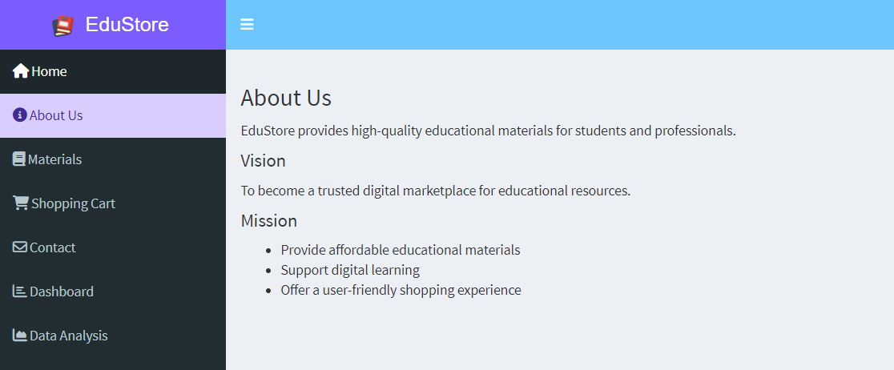

This page contains information about our company, our mission and our vision. This page has been prepared to provide users with information about our company, EduStore.

About Us Code
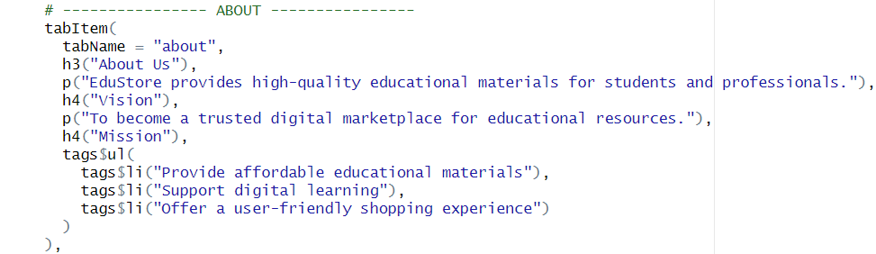

tabItem: Defines the content of a tab within the dashboard. Creates the page that will be displayed when the About tab is clicked.

tabName= “about” : This is the unique identifier of the tab. This content is displayed when the user clicks the “About” option in the menu.
h3(“About Us”) : This is the main heading of the "About Us" page.

p(): Paragraph text inserts.

h4(“Mission”) : It forms the institution's vision statement.

tags$ul() : It corresponds to the <ul> (unordered list) tag in HTML. It creates a bulleted list. It presents mission statements in an organized and readable way.

tags$li() : It is a list item created with the <li> tag.

3-Products Page (Materials Page)
On this site, the "Products" page has been adapted for use as educational content and renamed "Materials".

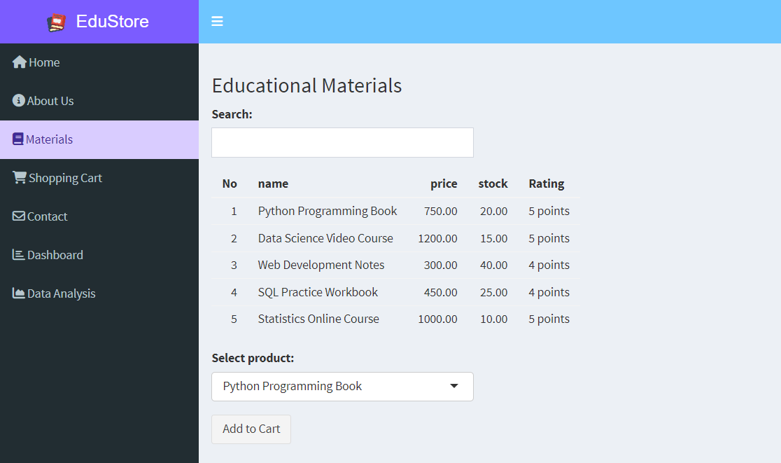

This page contains a list of our company's products. You can find the product you want to purchase using the search bar at the top of the page. You can select the product you want to buy from the "Select product" section and add it to your cart by clicking the "Add to cart" button. You can click on the "Shopping Cart" tab to view your cart. Products are deducted from stock as shown below when added to the cart.

Added to Cart Message

This message indicates that the product has been successfully added to the cart.
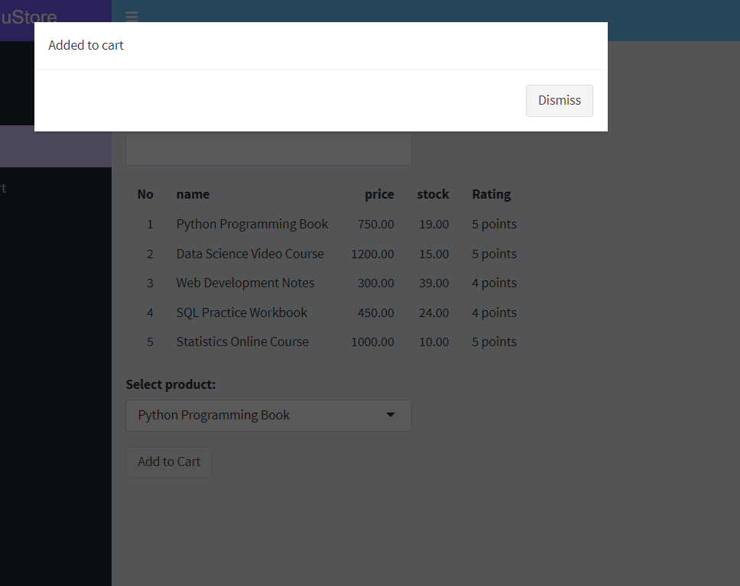

Products are being removed from stock

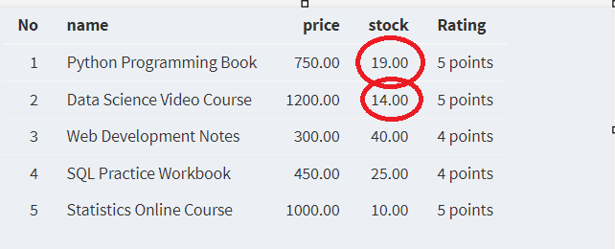

Products(Materials) Code
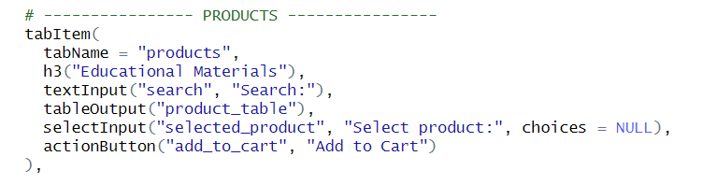

tabItem() : This defines the content of the Products tab within the Dashboard. This area is displayed when the user clicks the “Products” tab in the menu.

tabName = "products" : This is the unique identifier of the tab. This content is displayed when the user clicks the “products/materials” option in the menu.

h3("Educational Materials") : This heading indicates that the products are educational materials.
textInput("search", "Search:") : It is used to receive text input from the user. "search" is the ID value of the input. The search operation on the server side is performed using this ID. "Search:" is the label part visible to the user. It allows the user to search among products.

tableOutput("product_table") : It is used to display a product list in a table format.

selectInput("selected_product", "Select product:", choices = NULL) : Creates a dropdown list allowing the user to select a product. "selected_product" is the ID of the selected product. "Select product:" is the description text displayed to the user. choices = NULL specifies that the options will be dynamically populated on the server side. This field is updated as the product list changes.

actionButton("add_to_cart", "Add to Cart") : Creates a button that the user can click. "add_to_cart" is the button's ID. When this button is pressed on the server side, the action is performed. "Add to Cart" is the text that appears on the button. It adds the selected product to the shopping cart.

4- Shopping Cart Page
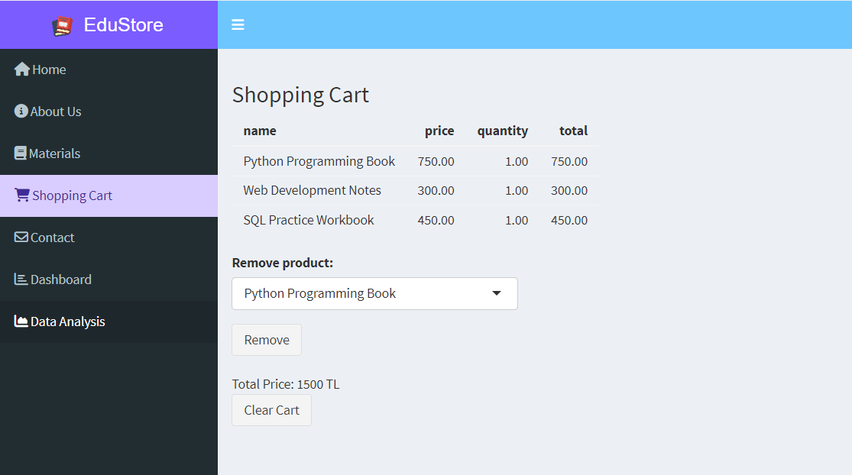

On this page, you can see the products you've added under the "Materials" tab; this page is your shopping cart. You can select the product you want to remove from the dropdown list under "Remove product" and click the "Remove" button. If you want to remove all products, you can click the "Clear Cart" button. The text between the "Remove" and "Clear Cart" buttons shows the total amount of products in your cart.

When you click the "Clear Cart" button, it will look like this:
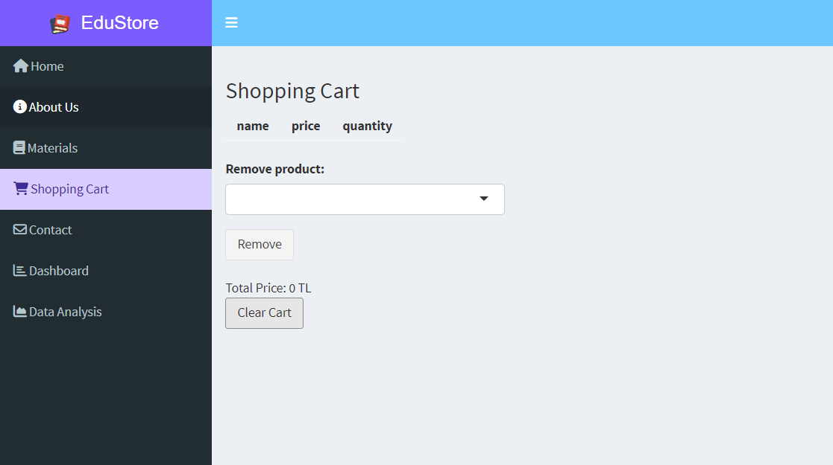

Shopping Cart Code
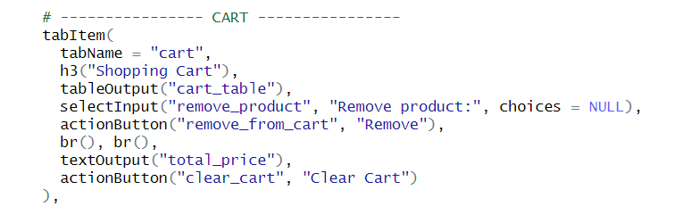
tabItem() : This defines the content of the Cart tab within the Dashboard. This area is displayed when the user clicks the “Shopping Cart” tab in the menu.

tabName = "cart" : This is the unique identifier of the tab. This content is displayed when the user clicks the “cart” option in the menu.

h3("Shopping Cart") : This heading indicates that the user is currently on the shopping cart page.

tableOutput("cart_table") : It is used to display the products in the shopping cart in a table format. "cart_table" is the ID of the shopping cart table created on the server side.

selectInput("remove_product", "Remove product:", choices = NULL) : Allows the user to select the product they want to remove from the cart. "remove_product" is the ID of the selected product. "Remove product:" is the description label visible to the user. choices = NULL specifies that this list will be dynamically populated based on the products in the cart.

actionButton("remove_from_cart", "Remove") : This button is used to remove items from the cart. "remove_from_cart" is the button ID. When this button is pressed on the server side, the deletion process is performed. "Remove" is the text displayed on the button.
br() : It leaves a blank line on the page.

textOutput("total_price") : "Total_price" displays the total price of the items in the cart as text. "total_price" is the ID of the total amount calculated on the server side. It is a dynamic output; it is automatically updated as items are added to and removed from the cart.

actionButton("clear_cart", "Clear Cart") : Used to delete all items from the cart at once. "clear_cart" is the button ID. "Clear Cart" is the description text that appears on the button. It is a feature that facilitates user experience.

5- Contact Page
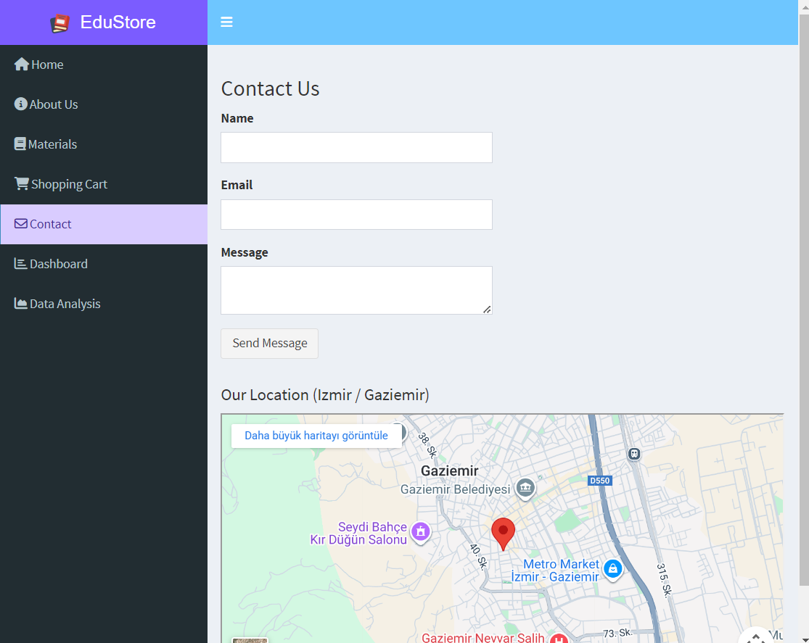

This page contains a form where users can contact our company and send messages. When the user clicks the "Send Message" button, a message will appear on the screen indicating that the message has been sent. The user can see our company location on the map below the button and view it via Google Maps.

Notification that appears when a message is sent:
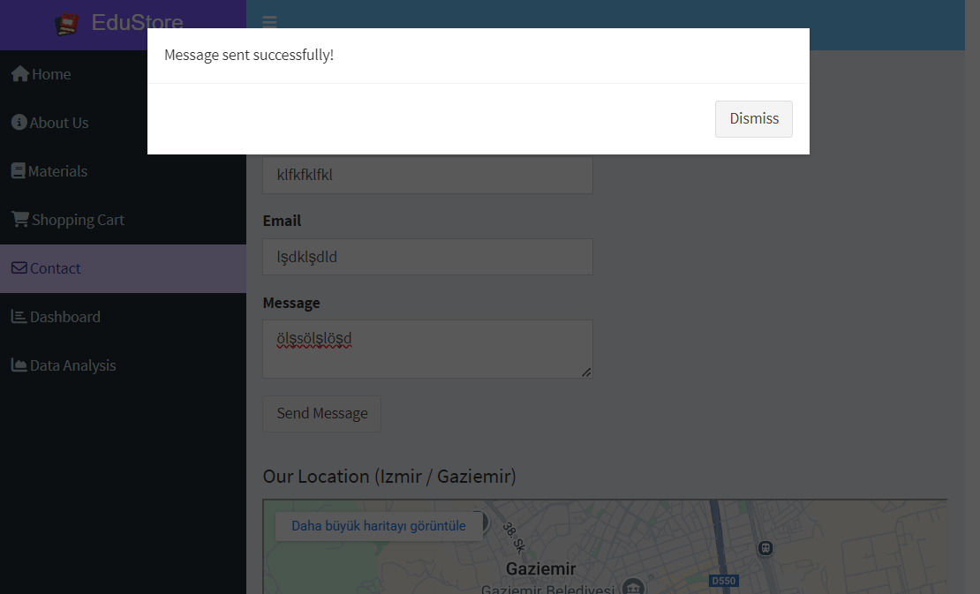

Contact Page Code
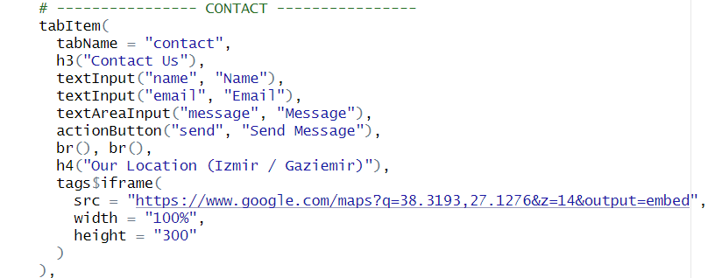

tabItem() : This defines the content of the Contact tab within the Dashboard. This area is displayed when the user clicks the Contact tab in the menu.

tabName = "contact" : This is the unique identifier of the tab. This content is displayed when the user clicks the “contact” option in the menu.

h3("Contact Us") : It is clearly stated to the user that this page is a contact form.

textInput("name", "Name") : It creates a text box for the user to enter their name. "name" is the ID value of the input. On the server side, this data is retrieved via this ID. "Name" is the label text visible to the user.

textInput("email", "Email") : It is used for the user to enter their email address. "email" is the Input ID. "Email" is the descriptive label of the form field. It is one of the basic components of the contact form.

textAreaInput("message", "Message") : It allows the user to enter long text. It is used to write messages, suggestions, or feedback. "message" is the ID of the entered message. "Message" is the description visible to the user.

actionButton("send", "Send Message") : This button is used to submit the contact form. "send" is the button ID. When this button is pressed on the server side, the message sending process is triggered. "Send Message" is the text that appears on the button.

h4("Our Location (Izmir / Gaziemir)") : It specifies the physical location of the company. It provides location information to the user.

tags$iframe() : It allows you to use the <iframe> tag in HTML within Shiny. It embeds external content (such as Google Maps) into the page.

src = "..." : Specifies the source address of the map to be displayed. output=embed This embeds the map into the page.

width = "100%" : It allows the map to fill the entire page horizontally. It creates a responsive design.
height = "300" : Sets the map's vertical height to 300 pixels. Ensures the map is clearly visible without disrupting the page layout.

6-Dashboard Page
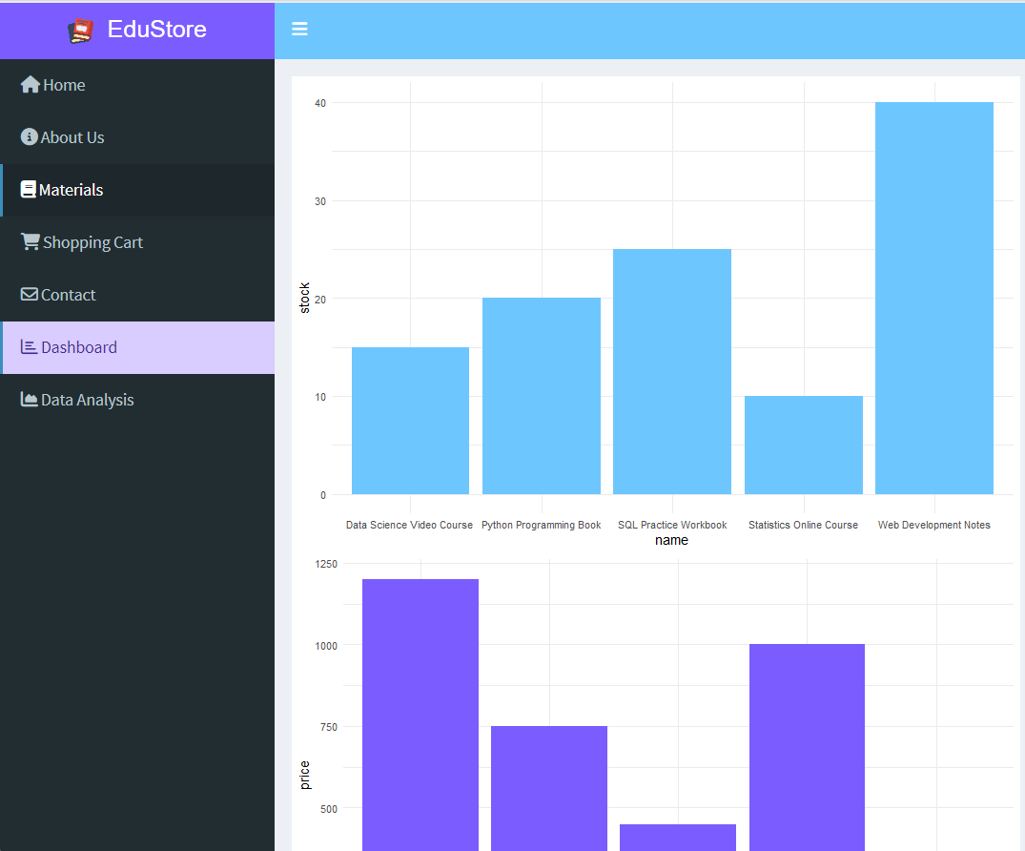
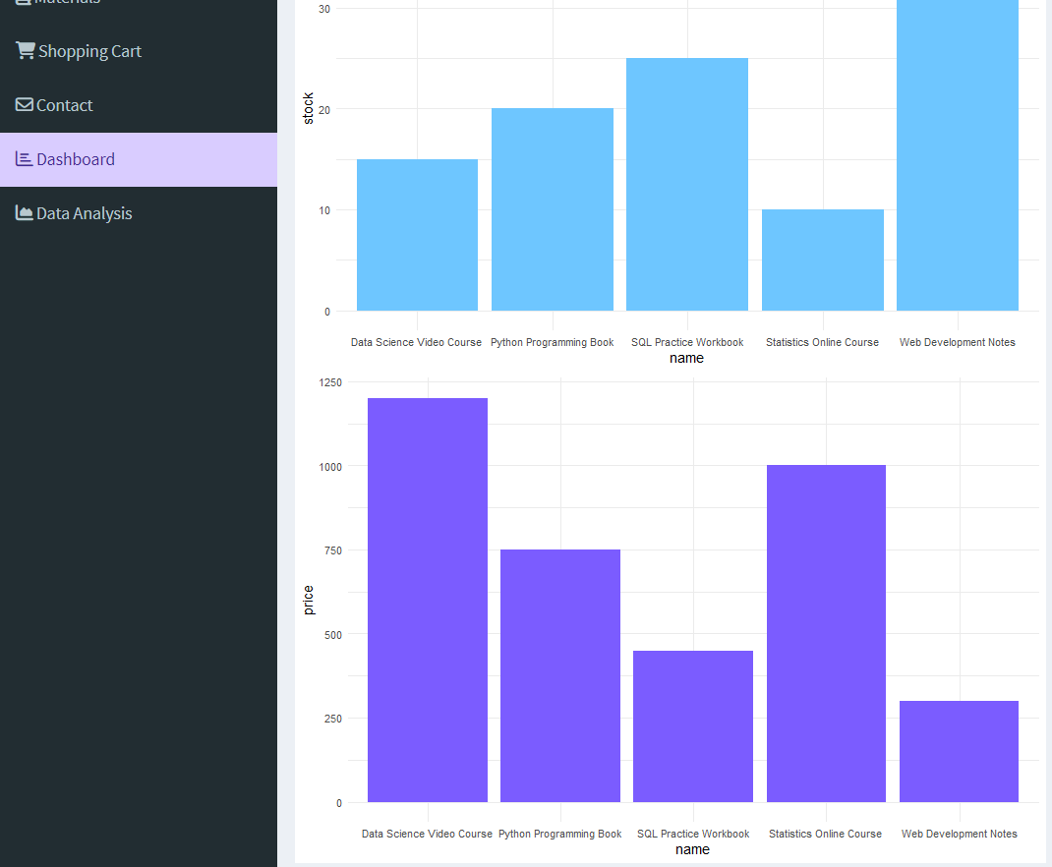
The "Dashboard" section of the EduStore platform is where inventory data is graphically analyzed and provides decision-makers with a visual summary. This page contains bar charts for product-stock and product-price data. This page interprets data through two main charts created using the ggplot2 library.

Stock Distribution Chart (Light Blue Chart above): This bar chart visualizes the warehouse stock status of each training material.
Price Distribution Chart (Purple Chart below):This chart presents a comparative overview of the unit prices of the products.
Graphical Features
Interaction: The graphs clearly separate the values ​​(y-axis) of products according to their names (x-axis).
Theme: The theme_minimal() design is used to improve readability, providing a professional look free from clutter.

Dashboard Page Code
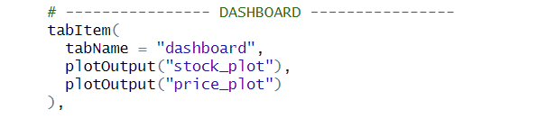

tabItem() : This defines the content of the Dashboard tab within the Dashboard menu. This area is displayed when the user clicks the Dashboard tab in the menu.

tabName = "dashboard" : This is the unique identifier of the tab. This content is displayed when the user clicks the “dashboard” option in the menu.

plotOutput("stock_plot") : It is used to display a graph (plot) within the application. "stock_plot" is the ID of the graph generated on the server side. This graph is used to visualize product stock status and compare stock quantities.

plotOutput("price_plot") : It creates a second graph area. "price_plot" is the ID of the graph showing product prices. This graph is used to show price distributions and price comparisons between products.

7-Data Analysis Page
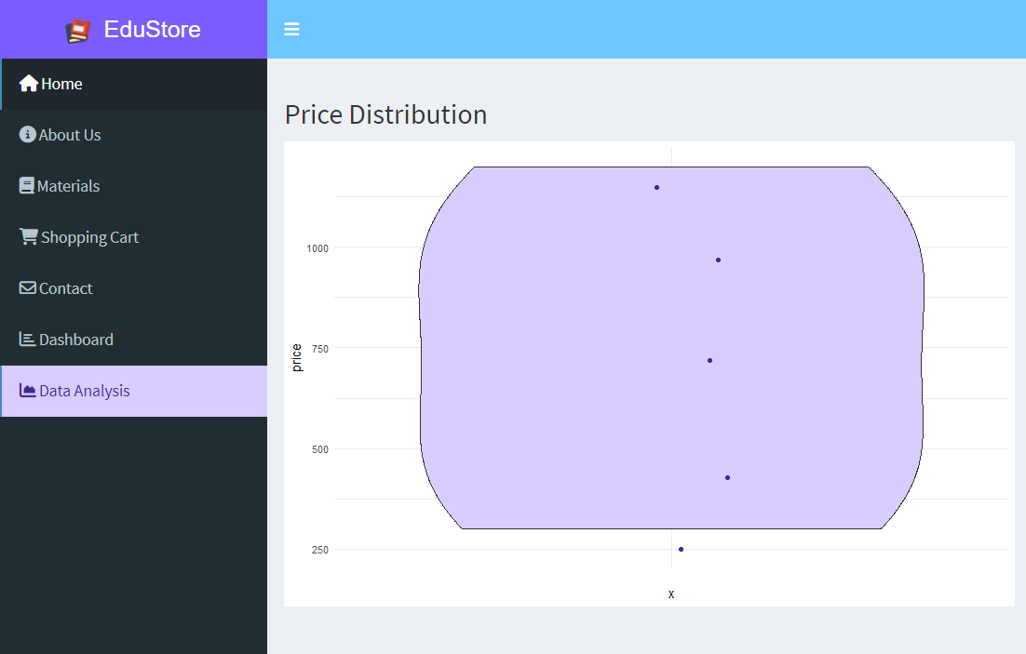

This page displays the Violin Chart graph of Price Distribution.The "Data Analysis" tab uses a Violin Plot to delve deeper into the pricing structure of the product portfolio:

Density Analysis: The larger areas on the graph show where prices are concentrated.
Data Points (Jitter): The points on the graph represent the exact position of each product on the price scale. This visualization is critical for determining whether the price distribution between 300 TL and 1200 TL is balanced and identifying outliers.

Data Analysis Code
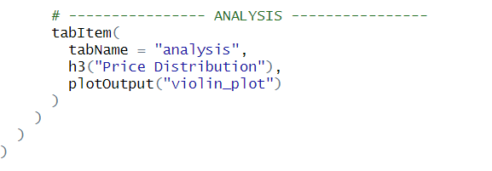

tabItem() : This defines the content of the Analysis tab within the Dashboard. This area is displayed when the user clicks the Analysis tab in the menu.

tabName = "analysis" : This is the unique identifier of the tab. This content is displayed when the user clicks the “data analysis” option in the menu.

h3("Price Distribution") : It states that the data being analyzed is the price distribution. It explains the purpose of the graph to the user.
plotOutput("violin_plot") : This is the output field used to display the violin plot. "violin_plot" is the ID of the graph generated on the server side. Violin plot: Allows for visual analysis of price distribution, densities, and outliers.

Server Part
The server side of the Shiny application enables dynamic data management based on user interactions via input$ objects. input$search filters products, input$selected_product identifies the selected product, and input$add_to_cart and input$remove_from_cart perform cart and cart removal operations; input$clear_cart completely clears the cart and restores stock. Thanks to the reactive and reactiveVal structures, product and cart data are automatically updated and stock control is ensured. The renderTable function displays product and cart information in a table format, while renderText calculates and presents textual outputs such as total price to the user. Additionally, the observe and observeEvent functions update dropdown lists, execute actions when buttons are pressed, and display warning messages. Dashboards (valueBoxes) display total product, order, and sales information, create graphs, and display an informational message when a contact form is submitted using input$send.

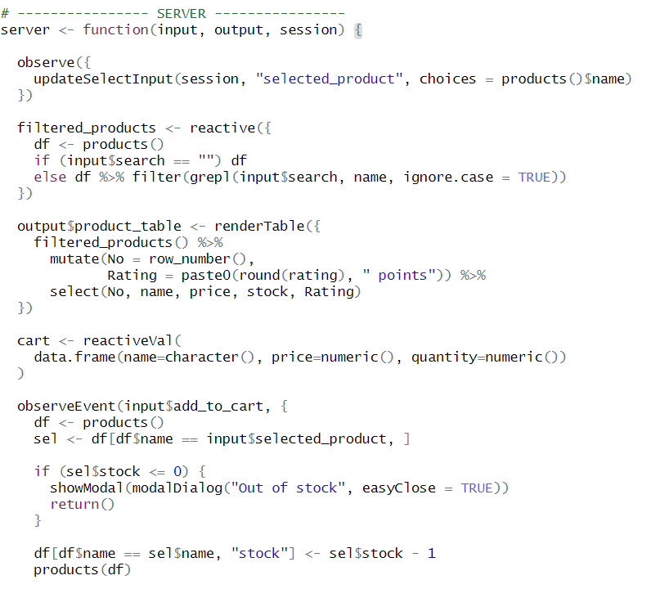
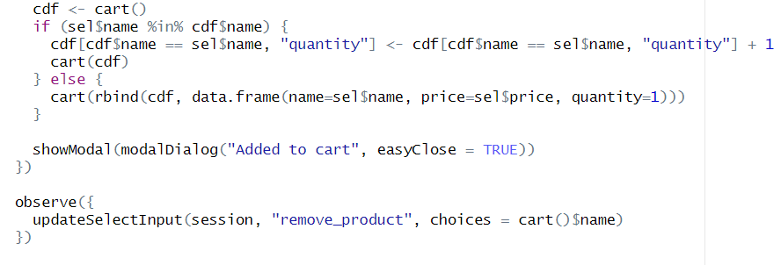

a) Fixed Remove (Reducing 1 Item from the Cart and Clearing the Cart):
This section manages the processes of removing products from the cart and completely clearing the cart. The observeEvent(input$remove_from_cart) function runs when the user presses the Remove button and checks if the selected product is in the cart. If the product is found, the product's stock value is increased by 1 using the products() data. Then, the quantity of the product in the cart is checked, if the quantity is greater than 1, the quantity value is decreased by one, and if the quantity is 1, the product is completely removed from the cart list. The observeEvent(input$clear_cart) function completely clears the cart and restores the stock quantity for each product in the cart to the same quantity as the cart's original stock. After these operations, the product and cart data are updated.

Cart Table and Total Price :The cart contents are displayed to the user as a table using the renderTable function. If there are products in the cart, the total amount is calculated for each product based on price and quantity and added to the table. The renderText function calculates the total price information; If the basket is empty, "Total Price: 0 TL" is displayed; if it is full, the total price and quantity of all products are presented to the user as text.

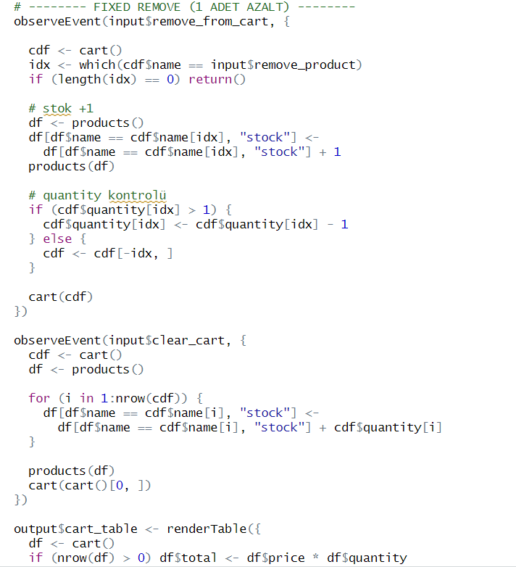
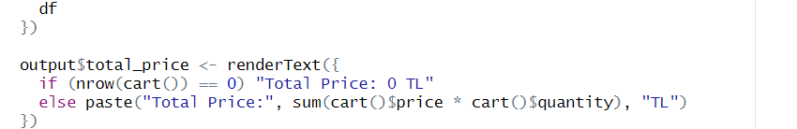

b)Home Summary:The information on the main page is created using renderValueBox functions. The total number of products is calculated using the number of rows in the product dataset. The total sales amount is calculated by summing the products of the prices and quantities of the products in the basket. The total number of orders is calculated by summing the quantities of all products in the basket. Thanks to these valueBox structures, the overall status of the application is shown on the main page as summary information.

Contact Form:The observeEvent(input$send) function runs when the user presses the Send button on the contact form and displays a notification (modalDialog) indicating that the message has been successfully sent.

Graphs:Visual analyses of the products are created using renderPlot functions. The stock graph shows the current stock status of the products, and the price graph shows the product prices in a bar graph format. The Violin plot visualizes the distribution of product prices, allowing for clearer analysis of price ranges using points. The theme_minimal() is used for a simple appearance in the graphs.

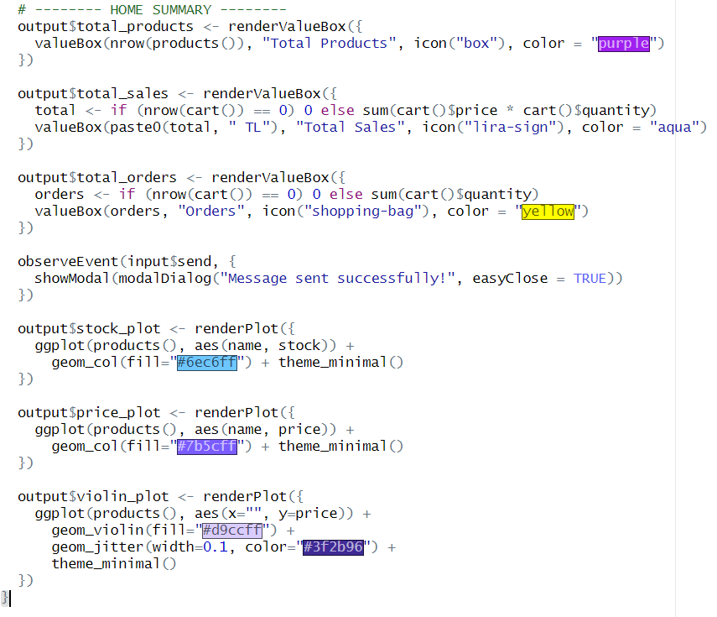

c)Server Execution Function
The shinyApp(ui, server) function combines the user interface (UI) and server components to execute the Shiny application.


